Penetration Testing With The Metasploit Framework:

Perform and automate the penetration testing life cycle.

PTES (Penetration Testing execution standard)
various phases that make up the penetration test.

Phases:
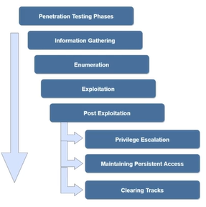

Bash history file (Kali/Linux): stores the list of commands a user typed in the terminal.
~/.bash_history (for the logged-in user). Root’s history is /root/.bash_history

Event Log (Windows): records system, security, and application events (like logins, errors, installs).
stored as .evtx files in C:\Windows\System32\winevt\Logs\ (viewable via Event Viewer eventvwr.msc; admin privileges are usually required).

